Just City Workshop

A Global Partnership Building between

Centre for Researching Cities (Newcastle) & Urban Academy (Helsinki)

Workshop Programme

15-16 May 2023
Newcastle University

Armstrong Building
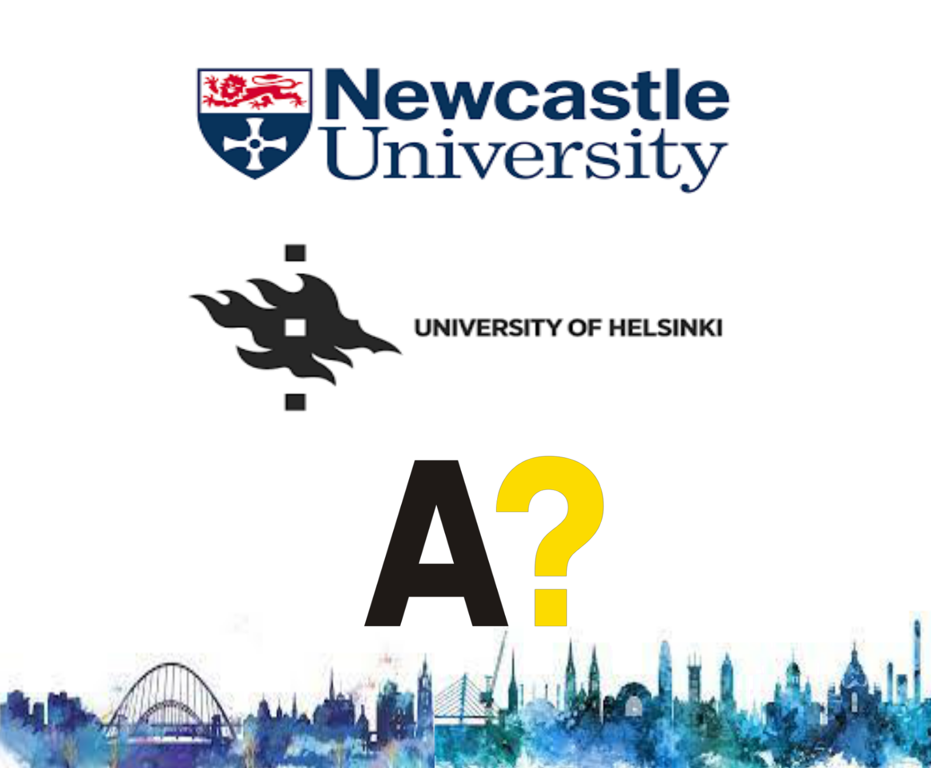
ARMB.G.70 Reception Rooms and Lounge

Aim

This is the first in a series of workshops that aim to: deepen existing research collaborations between Centre for Researching Cities (Newcastle University) and the Institute of Urban and Regional Studies (Urbaria at the University of Helsinki) and Living+ network (Aalto University), enhance place-based engagements with policy makers and practitioners, and enrich international collaborative experiences for students in the three universities.

Format

The workshop is structured around four just city’s sub-themes. Each sub-theme session is introduced briefly by 2 participants from Newcastle and Helsinki. This will be followed by small group discussions aimed at formulating research questions/topics for future research and workshop activities. The final session focuses on developing a detailed programme for a student-centred collaborative project.

Programme – Monday 15th May 2023
Armstrong Building (Building 22 on campus map)

Monday 15 May 9.00-17.00

Welcome and introductions

Chair: Simin Davoudi

9.00-9.10 Nigel Harkness (PVC HASS)
9.10- 9.20 Paula Gazzola (Head of APL)

9.20 – 10.20 Roundtable introductions and desired outcomes: all

10.20 -10.30 Workshop format

10.30-10.45 Break

Sub-theme 1: Cities and environmental (in)justices

Chair: Danny MacKinnon
10.45-11.00 Simin Davoudi

11.00-11.15 Marketta Kytta

11.15- 12.30 Group discussion

12.30-13.30 Lunch

Sub-theme 2: Cities and social (in)justices

Chair: Gillian Jein

13.30-13.45 Jani Vuolteenaho and Johanna Lilius
13.45-14.00 Darren McCauley

14.00- 15.00 Group discussion

15.00-15.15 Break

Sub-theme 3: Financialisation and de-regulation of urban growth

Chair: Ali Madanipour
15.15-15.30 Mari Vaattovaara

15.30-15.45 David Webb

15.45-17.00 Group discussion

Programme – Tuesday 16th May 2023
Armstrong Building (Building 22 on campus map)

Tuesday 16 May 9.30-12.30

Sub-theme 4: Urban governance and (un)equal participation

Chair: Gabriel Silverstre

9.30-9.45 Stephen Elstub
9.45-10.00: Ira Verma and Niharika Singh (online)
10.00-11.00 Group discussion

11.00-11.15 Break

11.15-12.30: Students’ collaborative project / colloquium (process and content)
Chair: Emma Ormerod

Newcastle Coordinator: Ellis Douglas
Finland Coordinator: Mikko Posti

12.30 Lunch and close

13.30-16.30 Excursion

The Farrell Centre (guided by Owen Hopkins) and Newcastle City centre and riverside developments (guided by Ellis Douglas)

Thank You to Our Participants

Newcastle University

Simin Davoudi
Ellis Douglas

Stephen Elstub
Paula Gazzola (welcome)

Nigel Harkness (welcome)
Owen Hopkins

Gillian Jein
Danny MacKinnon

Darren McCauley
Ali Madanipour

Emma Ormerod

Gabriel Silvestre
David Webb

Urban Academy

Timo Cantell
Sa Haoxuan

Hossam Hewidy

Marketta Kytta

Mikko Posti

Niharika Singh

Mari Vaattovaara
Ira Verma
Jani Vuolteenaho

